

.

Minutes of the Parish Council Meeting held at Freeland Village Hall in the Newell Room at 19:30 on Monday 13th October 2025

Members Present:
Cllr P Foster (PF), Cllr M Canning (MAC), Cllr R Crocker (RCR), (MC), Cllr V Baker (VB), Fay Friend (FF), District Cllr R Faulkner and County Councillor L Walker
Minute | Agenda Number | Minute
25.10.1 | 1 | Apologies for absence:  There were apologies for absence from Cllr R Clark (RCL), Cllr M Andrews (MA), Cllr P Holt (PH) and District Cllr L Arciszewska
25.10.2 | 2 | Declaration of pecuniary interest and request for dispensation:  It was RESOLVED there were no declarations.
25.10.3 | 3 | Minutes if the last meeting:  It was RESOLVED to approve the minutes of the meeting dated 15th September with the minor amendments. The chair signed the minutes.
25.10.4 | 4 | Public participation:  There were 2 members of the public present.  A resident wanted to raise concerns about traffic calming for the village green. It was agreed to raise with Cllr Liam Walker during the meeting – see 25.10.16-9biv below.
25.10.5 | 5 | Planning: To receive update on new and existing planning applications and comment where required.  Applications received:  25/01928/HHD- it was RESOLVED comment on the fact that it is retrospective although the council would not have had any objections to the porch. We would also highlight the additional access point affecting those walking to school.
25.10.6 | 5 | Planning: To receive update on new and existing planning applications and comment where required  Applications approved:  25/01778/HHD: Approved
25.10.7 | 5 | Planning: To receive update on new and existing planning applications and comment where required  Applications refused: none  Applications withdrawn: none  Applications appealed: none
25.10.8 | 6 | Reports from District and County Councillors:  Liam Walker:  Oxford congestion charge comes in on the 29th of October. A Traffic Order has been approved preventing right turns onto A40 at Barnard Gate. Oxfordshire has been rated Good in the latest CQC report for adult social care.
25.10.9 | 6 | Reports from District and County Councillors:  Lidia Arciszewska:  No update
25.10.10 | 6 | Reports from District and County Councillors:  Roger Faulkner:  No update
25.10.11 | 7a | To Discuss and Approve financial matters:  To approve invoices for payment  It was RESOLVED to pay the account presented, proposed by MAC and seconded by VB  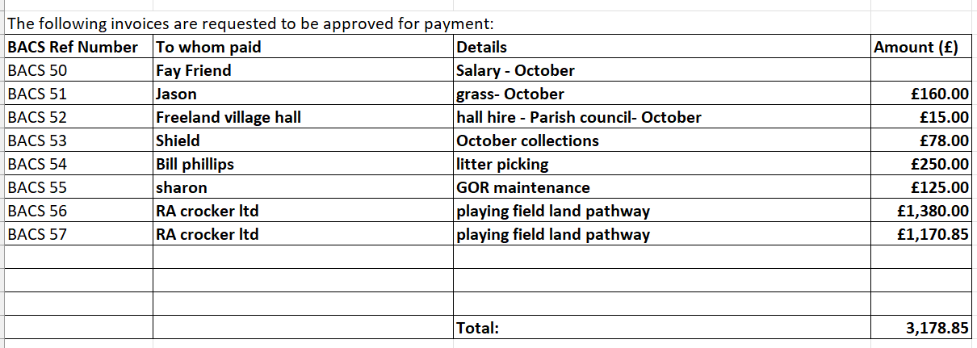
25.10.12 | 7b | To Discuss and Approve financial matters:  - To approve bank reconciliation- These were signed by PF
25.10.13 | 7c | To Discuss and Approve financial matters:  To note council income-  Second half of the precept has been received.
25.10.14 | 8 | Website- Updates to add
25.10.15 | 9a | Parish Matters:  Play Areas/Playing Field/Play Equipment Book – a hole in the membrane under junior swings needs fixing. RC to look into temporary fix using geotextile membrane and adhesive. It was RESOLVED to ask contactor installing new equipment to give advice on permanent solution.  Boundary to garden on Pigeon House Lane - it was RESOLVED for RC and MAC to meet with resident.  i. Land registry- Update – we are awaiting further instructions.  ii. Use of the Cricket pitch - it was RESOLVED for PF to speak to Freeland cricket club about the hire of the pitch, ball strikes and lease.  iii. Pitch drainage- the potential grant requires Environment agency approval – this could be problematic due to the single outfall. It was agreed that the football club should apply for necessary approvals as part of the grant application process.
25.10.16 | 9b | Parish Matters:  Village Maintenance and Highway Matters  i. VAS Signs- it was RESOLVED to approve the quote for the tree works.  ii. Garden of Remembrance – replacement of gate post to allotments - need to check on the lease with the allotment association concerning ownership of gate.  iii. Stagecoach- it was RESOLVED to write to stagecoach requesting if Witney – Oxford buses could run through the village with at least one stop.  iv. Speeding - Cllr Liam Walker suggested obtaining speed data to back up the need for traffic calming by The Green. The PC can then explore options with highways. He also suggested revisiting the traffic calming plan prepared by the PC a few years ago. The signage needs to be clearer with a village ‘gateway’ on the hill from the south towards The Green, highlighting that you are entering the village. Other suggestions include raising the kerb along the edge of the Green itself. It was RESOLVED to get in contact with highways to explore solutions.
25.10.17 | 9c | Parish Matters:  Village Hall Management committee.  i) signage- it was RESOLVED to not fund a sign.
25.10.18 | 9d | Parish Matters:  Freeland Energy Group- there was no update.
25.10.19 | 9e | Parish Matters:  Previous months actions (if not already resolved)  It was RESOLVED to go through the actions list and implement before the next meeting where required
25.10.20 | 10a | Governance:  OALC updates- no update
22.10.21 | 11 | To receive reports from councillors representing the Council on outside meetings  None
25.10.22 | 12 | Items for information only  none
25.10.23 | 13 | To note the date of the next Parish Council meeting  10th November 2025. 7.30 in the Newell room
Meeting ended at 21.08

Signed by Chairman

Date signed

