

.

Minutes of the Parish Council Meeting held at Freeland Village Hall in the Newell Room at 19:30 on Monday 12th January 2026

Members Present:
Cllr P Foster (PF), Cllr M Canning (MAC), Cllr R Crocker (RCR), Cllr P Holt (PH), Fay Friend (FF) District Cllr R Faulkner, District Cllr L Arciszewska, County Councillor L Walker
Minute | Agenda Number | Minute
26.1.1 | 1 | Apologies for absence:  There were apologies for absence from Cllr M Andrews (MA), Cllr R Clark (RCL), Cllr V Baker (VB),
26.1.2 | 2 | Declaration of pecuniary interest and request for dispensation:  It was RESOLVED there were no declarations.
26.1.3 | 3 | Minutes of the last meeting:  It was RESOLVED to approve the minutes of the meeting dated 8th December. The chair signed the minutes.
26.1.4 | 4 | Public participation:  There was 1 member of the public present.
26.1.5 | 5 | Planning: To receive update on new and existing planning applications and comment where required.  Applications received:  25/02888/HHD – 173 Wroslyn Road – no comments  25/02983/HHD- The Stables, Pigeon House Lane - no comments  25/02936/FUL- Methodist Church change of use –  it was RESOLVED to support the application.
26.1.6 | 5 | Planning: To receive update on new and existing planning applications and comment where required  Applications approved: 25/02624/FUL Cuckoo Wood Caravan Park  Applications refused: none  Applications withdrawn: none  Applications appealed: none
26.1.7 | 6 | Reports from District and County Councillors:  Liam Walker:  Booking system will come in on 14th January for recycling at Dix Pit. There will be an initial 6 week grace period.  Hanborough station- GWR café now open. From 19th January 30 more parking spaces will be made available. Feasibility study ongoing into additional parking.
26.1.8 | 6 | Reports from District and County Councillors:  Lidia Arciszewska:  May elections will go ahead in WODC as planned, despite LGR.  WODC have released a list online of developments that have been approved with Grampian conditions. The aim is to be clear that delivery of new housing is being held up by delays in upgrades to sewage infrastructure.  Expectations that the next stage of 100% affordable housing (70 homes at Woodford Way) will be approved at Executive Committee on Wednesday 14 January. Parking data for Marriotts car park has been reviewed to ensure it can cope with displaced cars and key workers will be allocated space there.  CIL has formally been adopted and will ensure WODC receive more from developments.  Carterton Masterplan in progress - 202 affordable homes delivered out of 276. District leisure has improved with more customers.  Waste and recycling - missed bin collections are down. Working with South Oxfordshire, Cherwell and OCC on waste, recycling and grounds maintenance to better utilize resources and give £100,000,000 saving over next 10 years.  Concluded 3 years working with Spacehive /Westhive funding - during this time nearly £1,000,000 has been donated to projects by the public. From April will move to Crowdfunding UK instead.
26.1.9 | 6 | Reports from District and County Councillors:  Roger Faulkner:  Fire service consultation closes 20th January – closure of Eynsham and Woodstock fire stations proposed - so it is encouraged to get comments in asap.
26.1.10 | 7a | To Discuss and Approve financial matters:  To approve invoices for payment  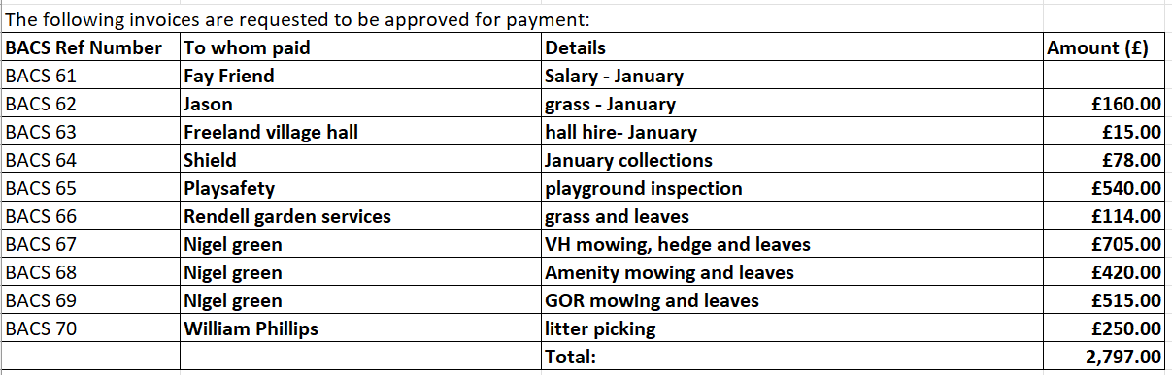  It was RESOLVED to pay the account presented, proposed by RC and seconded by MAC.
26.1.11 | 7b | To Discuss and Approve financial matters:  To approve bank reconciliation- These were signed by PF  Financial Review: 2025/2026.  Current Bank Balance = £130,191.39  The Financial Review and bank balance were NOTED.
26.1.12 | 7c | To Discuss and Approve financial matters:  To note council income-  None received
26.1.13 | 8 | Website- Updates to add  Nothing to be added
26.1.14 | 9a | Parish Matters:  Play Areas/Playing Field/Play Equipment Book  - Play equipment book with RCL. Play area - works to play area now completed apart from lining out all weather surface and remedial work to tarmac and it has now been opened agaon. It was agreed to delay payment and keep a small retention.
26.1.15 | 9b | Parish Matters:  Village Maintenance and Highways  - Leaves in front of church to be added on fix my street.  - VAS Signs- Morelock has gone into liquidation. Clerk to speak to RCL on the issues: avenues to try will be the bank and insurance company. Also potentially reclaim VAT.  - Garden of Remembrance - leaking tap to be looking into by RCR. New post supports needed for the trees - this plus installation of gates will be carried out over spring.
26.1.16 | 9c | Parish Matters:  Village Hall Management committee.  All is going well. Decoration has been finished for the hall and the toilets. Looking into gradually replacing chairs.  Issues with the Wi-Fi connection in the Newell Room need to be investigated.  Icy car park in the winter months issues - pathway is salted when possible but car park too large to effectively treat.
26.1.17 | 9d | Parish Matters:  Previous months actions (if not already resolved)  It was RESOLVED to go through the actions list and implement before the next meeting where required
26.1.18 | 10a | Governance:  OALC updates- no update  It was RESOLVED to book Hall for 15th May for Annual Parish Meeting and to contact all involved.
26.1.19 | 11 | To receive reports from councillors representing the Council on outside meetings  FEG – PF has agreed to take on liaison for PC.
26.1.20 | 12 | Items for information only  Fence on the green - boundary issues.  Thames Water are in the process of replacing burst pipeline in field behind Church View.
26.1.21 | 13 | To note the date of the next Parish Council meeting  9th February 2026 at 7.30 in the Newell room
Meeting ended at 21:15

Signed by Chairman

Date signed

